**Before the**

**United States Senate Committee on Finance**

**Washington, DC 20510-6200**

|  |  |  |  |  |
| --- | --- | --- | --- | --- |
|  | | | | |
|  |  |  |  |
| In the Matter of  United States Senate Committee on Finance Bipartisan Mental Health Request for Information |  |  |  |
|  |  |  |  |

**Comments of:**



**Digital Therapeutics Alliance (DTA)**

1405 South Fern Street, #90008

Arlington, VA 22202

**Dated: November 12, 2021**

Committee on Finance

United States Senate

219 Dirksen Senate Office Building

Washington, D.C. 20510

Submitted electronically via mentalhealthcare@finance.senate.gov

Re: United States Senate Committee on Finance Bipartisan Mental Health Request for Information

We are very grateful for the opportunity to comment on the United States Senate Committee on Finance Bipartisan Mental Health Request for Information (RFI). And we commend the United States Senate Committee on Finance for seeking innovative solutions to address behavioral health problems with creative and equitable policy solutions. The following comment will identify evidence-based ways in which statutory and regulatory changes can address mental health improvement and innovation as requested by the Committee on Finance, with a particular focus on considerations for equitable, high-quality, and sustainable implementation of digital therapeutics for behavioral health.

About the Digital Therapeutics Alliance (DTA): DTA was founded in 2017 as a 501(c)(6) non-profit trade association of industry leaders and stakeholders engaged in the evidence-driven advancement of digital therapeutics. As the leading international organization on digital therapeutic thought leadership and education, the Digital Therapeutics Alliance provides patients, clinicians, payors, and policymakers with the necessary tools to evaluate and utilize DTx products.

Our vision is to transform global healthcare by advancing digital therapeutics to improve clinical and health economic outcomes. Our mission is to broaden the understanding, adoption, and integration of clinically evaluated digital therapeutics with patients, clinicians, payors, policymakers through education, advocacy, and cross-industry collaboration.

DTA brings together leading organizations through worldwide collaboration to improve clinical and health economic outcomes by advancing the use of high quality, evidence-based digital therapeutics by patients, clinicians, payors, and policymakers. The DTA currently has about 70 members representing 17 countries.

## Background

The rapid acceleration of digital health solutions triggered by the COVID-19 pandemic, unfortunately did not result in equitable gains in access to mental health care or ensure quality or sustainable systems to provide consistent care as patients’ mental health needs continue. .1,2However, there is one category of medicine that could help mitigate these gaps; digital Therapeutics (DTx) deliver therapeutic interventions directly to patients using scientifically developed, evidence-based, and clinically evaluated software to treat, manage, and prevent diseases and disorders. DTx products are subject to rigorous patient-centered core principles, an industry code of ethics, and product development best practices. DTx products can be used independently, alongside medications, or in tandem with clinician-delivered therapy. Since most DTx interventions are delivered at least in part through Android and iOS smartphones or tablets, few technical barriers exist to the implementation and scalability of DTx products in a multitude of settings. As such, digital therapeutics have the ability to provide patients with asynchronous support and therapy when they are actively experiencing symptoms or are unable to immediately access their healthcare providers. Within this category, there is a core focus area on mental and behavioral health, delivering standardized treatments for anxiety, depression, panic disorder, PTSD, substance use disorder, and more. Unfortunately, access to digital therapeutics remains limited without clear and scalable pathways to provide coverage to these innovative products. limited. This is due to the absence of a defined benefit category in Medicare. With no benefit category, there is no ability for DTx products to be assigned a HCPCS code, resulting in poor adoption and widening of healthcare access gaps across public and private payers. This environment creates disparities in who can receive these types of safe and effective treatments, often resulting in a cash purchase as the only option.

To support implementation of equitable, high quality, and sustainable DTx interventions for mental health, we propose that a benefit category be designed or assigned for Software as a Medical Device (SaMD) and Software in a Medical Device (SiMD).

## Clinical Effectiveness

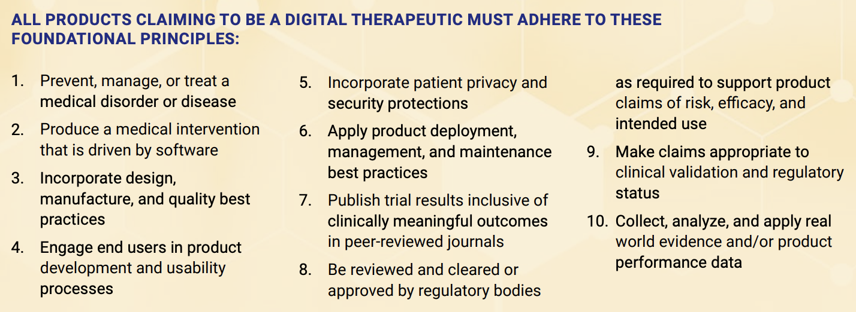

To help stakeholders understand and differentiate digital therapeutics from the thousands of other mobile health apps that are available, DTA developed a product library to highlight innovative, evidence based DTx that are currently on the market.

<https://dtxalliance.org/understanding-dtx/product-library/>

Within this library, there are clinically validated products that address mental health issues such as Daylight by Big Health for Generalized Anxiety Disorder, Deprexis by Orexo for depression, EndeavorRx by Akili for ADHD, Freespira by Freespira for PTSD panic disorder and panic attack, and reSET-O by Pear for SUD/OUD.

The literature demonstrates sufficient clinical evidence to warrant broader coverage and payment for DTx interventions that target mental health conditions. **In particular, Congress should create a benefit category for prescription digital therapeutics and diagnostics.** A productive template for legislative change is the bipartisan Prescription Digital Therapeutic Act.

## Fair Reimbursement

Historically, there have been multiple barriers to DTx coverage and payment, limiting availability for patients suffering from mental health issues. Despite these obstacles, DTx companies have found ways to get their products into the hands of patients who need them most, by making them available through employers, running pilots with commercial payers, gaining coverage on PBM’s digital health formularies, and finding unique value-based agreements. Additionally, there have been several examples of DTx products gaining coverage through public programs, such as Massachusetts recently covering Pear Therapeutics’ SUD/OUD DTx under their Medicaid program as well as the VA and Tricare covering DTx products to treat mental health and pain.

In general though, this patchwork of options does not provide consistent or broad coverage that would provide equitable care at a national level. This lack of clear or consistent pathways to patient access limits access to these products to small populations, often in privileged categories through employers, commercial payers, or cash pay.

## Conclusion

As the COVID-19 pandemic drags on, the mental health toll may continue to be exacerbated by ongoing viral evolution like the Delta Variant. With the help of Congress and CMS ensuring clear and scalable pathways to reimbursement, payers and technology companies can accelerate implementation of equitable, high quality, and sustainable treatment for mental health to deliver DTx innovations for those who need them. These recommendations can help innovators develop virtuous competitive advantages that help their companies succeed by helping humans thrive.

**Specific actions that Congress and CMS can take include**

* **Create a benefit category for prescription digital therapeutics**
* **Guarantee FDA-cleared digital therapeutics and diagnostics coverage and payment, at least provisionally**

We thank the United States Senate Committee on Finance Bipartisan for the opportunity to comment. DTA welcomes the opportunity to discuss these comments in further detail, as necessary. If you have any questions regarding these comments, please do not hesitate to contact us at 484-832-0614 or andy@dtxalliance.org.

Respectfully submitted,

**Digital Therapeutics Alliance**

By:

________________________________________

Andy Molnar

Chief Executive Officer

**Digital Therapeutics Alliance**

1405 South Fern Street, #90008

Arlington, VA 22202

**Bibliography**

1. Gassman-Pines, Anna et al. COVID-19 and Parent-Child Psychological Well-being. *Pediatrics*. 146 (2020).
2. Ford, Tasmin et al. Mental health of children and young people during pandemic. *BMJ*. 372 (2020).Prescription Digital Therapeutics Act. Capito SM. https://www.congress.gov/bill/116th-congress/senate-bill/3532