November 15, 2021

Senate Finance Committee Chairman Ron Wyden, D-Oregon
Finance Committee Ranking Member Mike Crapo, R-Idaho

Re: RFI from Senate Finance Committee for data-driven policy proposals designed to improve access to behavioral health care services for individuals enrolled in Medicare, Medicaid, CHIP, and ACA exchanges.

UPMC Western Psychiatric Hospital is the primary provider of inpatient behavioral health care for western Pennsylvania and is the flagship of UPMC Western Behavioral Health. It is a national leader in providing best practice, research-based care, and a broad array of innovative psychiatric and addiction services for all ages at every stage of recovery in both rural and urban areas of Pennsylvania.

Through our responses to the Committee questions in the following areas: a) strengthening the workforce; b) increasing integration, coordination, and access to care; c) and ensuring parity, we urge policymakers not to lose sight of the addiction and mental health crisis we faced before the onset of the pandemic, which has only been exacerbated by it. [Exhibit 1].

The pandemic has spurred increases in substance use, overdoses, depression, and anxiety. Studies have found that worry and stress related to COVID have had a major negative impact on many Americans’ mental health, particularly for those who have lost incomes or jobs.

Academic medical centers, like UPMC, play essential roles in clinical practice and research and are training the next generation of mental health and addiction providers who will meet the challenges of our national recovery. These centers need Congressional support and concerted effort by government at all levels, as well as private and public-sector stakeholders, to direct funding, resources, and public interest toward addiction and mental health. Failure to act risks undoing essential progress, a reduced and underprepared workforce, lost time in pursuit of important, live-saving innovations, and more preventable deaths.

With 263 licensed psychiatric beds, UPMC WPH admits more than 6,500 patients of all ages on an annual basis. For patients who come through the Psychiatric Emergency Services Department, more than 14,000 assessments are performed annually. When not admitted for inpatient care, the assessments are reviewed by management in an outpatient or community-based setting, totaling over 400,000 outpatient visits per year.

UPMC Western Behavioral Health encompasses the services available across the UPMC system. Joint programming with UPMC Children’s and UPMC Magee-Women’s Hospitals provides the behavioral health services to support children and women with their mental health needs and have strengthened our pediatric integrated care model over the past year. With 490 licensed psychiatric inpatient beds across nine UPMC hospitals, more than 12,700 children through seniors are admitted to inpatient care. Additionally, supporting outpatient services cover many counties throughout western Pennsylvania and UPMC WPH is recognized by the Human Rights Campaign as a leader in LGBTQ health care equality.

Last year, over 40% of surveyed adults reported a negative mental or behavioral health condition related to COVID-19, including 31% who reported anxiety or depression symptoms, 13% who started or increased their substance use, and 11% who seriously considered suicide over the past month. Those who are a parent and a caregiver of an adult report the highest rate of mental-health symptoms, reporting high levels of anxiety, COVID-19 TSRD (trauma- and stressor-related disorder), and alarmingly, a full 52 percent experienced “active suicidal ideation,” sometimes referred to as serious suicidal thoughts. UPMC mental health professionals can attest to these trends along with pediatric-outpatient volume which has surged 30% in the first four months of 2021 compared with the year earlier. For the past six months, UPMC resolve Crisis Services has been handling hundreds of calls per day. As many as 50 of them are serious enough to require a home visit by trained clinicians— this is two to three times the level of two years ago.

EXHIBIT 1

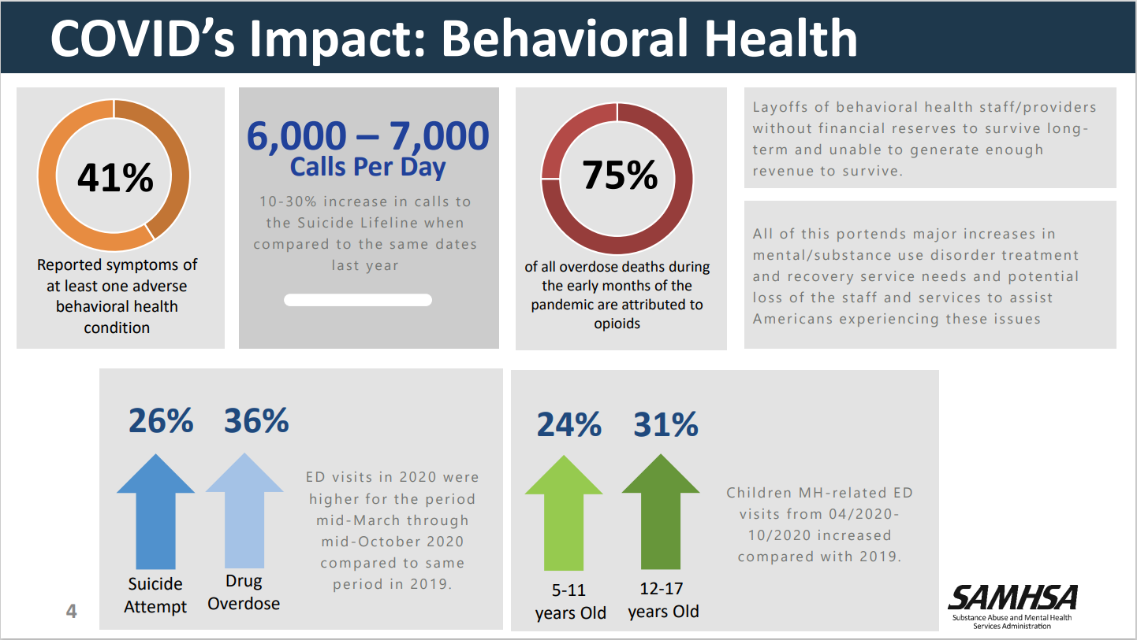

It is critical that we address these troubling trends through expanded access to effective mental health treatments, supportive interventions, and follow up. We applaud the American Rescue Plan Act (ARPA) signed by President Biden in March 2021 that sets aside about $4 billion to fund a myriad of mental healthcare initiatives, including funds for behavioral health workforce education and training [Exhibit 2].

When asked about short-term policy solutions to meet increased demand, UPMC Western Psychiatric and Behavioral Health aligns with industry partners – National Association of Behavioral Healthcare and National Council for Mental Wellbeing – in requests for additional funding to hire qualified staff, continue offering telehealth services, update reimbursement rates, and reduce the amount of paperwork/regulation that causes a burden to staff.

Senate Finance Questions on Strengthening Workforce
- What policies would encourage greater behavioral health care provider participation in these federal programs?
- What barriers, particularly with respect to the physician and non-physician workforce, prevent patients from accessing needed behavioral health care services?
- What federal policies would best incentivize behavioral health care providers to train and practice in rural and other underserved areas?
- Are there payment or other system deficiencies that contribute to a lack of access to care coordination or communication between behavioral health professionals and other providers in the health care system?
- Should federal licensing and scope of practice requirements be modified to reduce barriers for behavioral health care workers seeking to participate in federal health care programs? If so, how?

UPMC Western Premise:
Strengthen workforce through increased capacity, reimbursement, certified peers

We MUST increase the workforce to meet the demand.

Ramping up value-based models such as embedding mental health workforce into primary care practices and home and community-based services settings will fall flat without increased capacity of mental health workforce as part of larger comprehensive public health pandemic strategy to address increased mental health demands.

There are provider shortages across the entire healthcare spectrum. Data released in April 2021 by the Health Resources & Services Administration (HRSA) identifies shortfalls in the following areas:

EXHIBIT 2
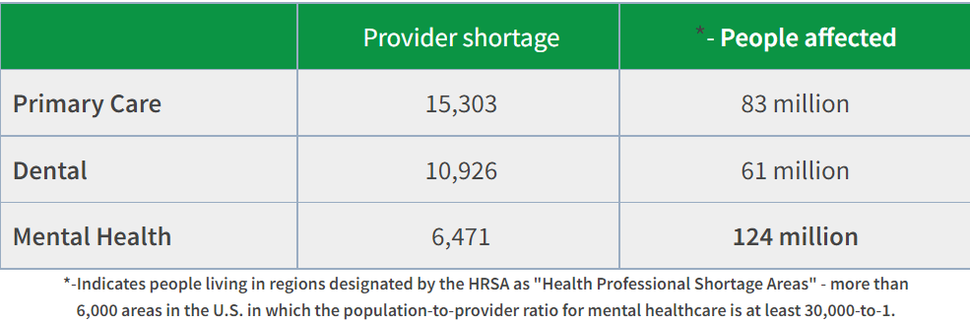

We call for majors shifts in the health care workforce to address the increasing demand for mental health and addiction services and the limited capacity in the following ways:

- Improving reimbursements from Medicare, AND Medicaid, AND, ensuring that they are adequately reflected in Commercial payment rates for Behavioral Health and Addiction Services. This request is both about increases, and Parity with physical medicine.
UPMC supports efforts to enhance compensation for mental health, addiction, and crisis services to allow for fairer pay of service providers for important and demanding work. Legislation to require increased reimbursement rates for providers to levels that are more consistent with their education and credentialing, comparable with how reimbursement rates are set for Physical medical providers. This will encourage more behavioral healthcare providers to participate in the program. Moreover, because Medicare rates tend to be key benchmarks for reimbursement in commercial insurance, improvements in Medicare reimbursement should lead to better reimbursement in commercial plans and potentially Medicaid programs as well.

- Congress should encourage CMS to incentivize states to reexamine and improve their Medicaid rates for behavioral healthcare providers to encourage greater participation in Medicaid. One step would be for Congress to expand the Demonstration to Increase Substance Use Provider Capacity in Medicaid (authorized by Sec. 1003 of the SUPPORT Act).

A decade ago, we were competing for staff with other mental health agencies. Today, we are competing with Costco, the Transit Authority, and gas stations because their pay rates have increased substantially while ours have not. The U.S. Bureau of Labor Statics reports that the median salary for social workers, which includes therapists, was $51,760 in 2020. As a result of these market forces, it could take families months to find appropriate mental health care, especially in ambulatory settings. The shortage of mental health professionals who work with kids and teens went from bad to worse in the U.S. during the pandemic.

- Psychiatrists and addiction specialists remain in short supply. While the demand for care is rapidly growing, the number of mental health professionals is barely holding even. As reported by Pennsylvania Legislative Budget and Finance Committee in February 2021, 66% of Pennsylvania Mental Health Administrators indicated that the lack of psychiatrists was contributing to delays in obtaining evaluations. This underscores the need to integrate mental health and addiction treatment into primary care and ensure that those providers have the skills necessary to screen, assess need, and provide treatment or refer as needed.

- Expand scholarships and loan repayment programs. The high cost of training and student loan debt may also create barriers for mental health practitioners to participate as Medicaid providers; Medicaid payment yields on average only 52% of private insurance and providers must be able to cover their costs to remain viable.

  - Expanding the recruitment pipeline for mental health specialty workers, such as psychiatrists, psychologists, and social workers will help meet the needs of underserved areas. Policies for doing this include expanding scholarship, fellowship, and loan forgiveness programs that attract more individuals, support more-diverse students, and require a commitment to practicing in high-need settings.

  - Recruitment and retention of underrepresented students and reductions in financial barriers to advanced degrees in mental health educational programs is one way to diversify the pipeline of mental health professionals, improving cultural competence and health outcomes. Consider peer-based strategies and coverage for these services. Health related careers should be better represented in STEM programming, fund, and policies.

  - UPMC is supportive of enhanced federal opportunities such as the Behavioral Health Workforce Education and Training grant through HHS. The University of Pittsburgh’s School of Social Work has received $1.87 million to grow the number nation’s mental health clinicians, which was unable to meet the needs of American children even before the pandemic. Starting in 2022, the grant will provide one-time $10,000 stipends over a period of four years to more than 100 graduate students. (For Pitt’s two-year Master of Social Work program, tuition is $11,765 a semester, or $47,060 total.) Stipend recipients will do field work, and take specific courses that focus on children and young adults. Graduate students who receive these stipends will do their field training at one of several sites in the Pittsburgh area, including Adolescent Medicine at UPMC.

- Congress and relevant federal agencies should take additional actions to expand the MH/SUD workforce addressing the full spectrum of treatment professionals, nonprofessionals, and peer support workers along the entire behavioral healthcare continuum including through loan repayment and grant programs. Peer-support specialists are people who have experienced mental health or substance use problems and been trained to support those struggling with mental health conditions, psychological trauma, or SUD. Certified Peer Specialists have been proven highly effective in improving patient outcomes. Expanding access to training, credentialing, and reimbursement for peer support has the potential to improve sustainable access to high-quality peer-support care.

- UPMC Western has engaged/expanded the involvement of Peer Navigator and Certified Peers where possible for follow-up care after a hospitalization or as extension of outpatient behavioral health or addiction services. With 51 employees across the organization, an affiliate peer program is under development to scale availability of peer-support services by leveraging the employees of other community-based organizations that share a common geography with the Western catchment area. These community organizations are not traditional behavioral health providers, but social service organizations, which share the common goal of improving engagement of people in need by making social services available to them.

- Continue insurance coverage for telehealth. The use of telehealth allows providers to reach underserved populations and provide care in rural areas. Stimulated by the COVID-19 pandemic, state and federal policymakers should codify expansion of these services by ensuring that insurers cover them so that clinicians are adequately reimbursed. From March 18, 2020- August 4, 2021, UPMC Behavioral Health Services completed 403,165 telemedicine visits for substance use disorders, including opioid, alcohol, cannabis, and tobacco. In addition to growing volumes among existing providers to improve access, UPMC Western is expanding its telepsychiatry presence across all hospital and community sites, including Emergency Departments.

- Given our response to the proposed rule, UPMC Western applauds CMS on MH/SUD provisions included in the Final Medicare Physician Fee Schedule for 2022. For telehealth services, the Medicare program will continue covering MH/SUD via telehealth after the public health emergency ends. CMS finalized its proposal to require in-person visits once every 12 months for those receiving behavioral health treatment via telehealth. CMS also will allow for exceptions to this 12-month interval if both the provider and patient agree the risks and burdens outweigh the benefits and this is documented. Moreover, Medicare will continue to cover audio-only telehealth for mental health and clarified that mental health services include treatment of SUD for purposes of Medicare coverage of audio-only telehealth.

- For Opioid Treatment Programs (OTPs), CMS will continue to cover individual and group therapy and substance use counseling provided by OTPs via audio-only, telehealth technology after the public health emergency ends.

Supportive Workforce Legislation

- Add 1,000 Medicare-funded hospital residency positions in addiction medicine, addiction psychiatry, or pain medicine, with 500 positions reserved for hospitals with existing programs in these specialties and 500 positions for hospitals creating new programs. The Ask: Consider and support passage of the Opioid Workforce Act of 2021 (S. 1438/H.R. 3441).

- Expanding the Medicare behavioral health workforce to include marriage and family therapists, mental health counselors, and peer support specialists would dramatically expand access to lifesaving care for Medicare beneficiaries. The Ask: Consider and support the passage of the Mental Health Access Improvement Act (S. 828/H.R. 432) and the Promoting Effective and Empowering Recovery Services (PEERS) in Medicare Act (S. 2144/H.R. 2767).

Senate Finance Questions on Increasing Coordination, Access to Care and Parity

- What are the best practices for integrating behavioral health with primary care? What federal payment policies would best support care integration?
- How could Congress improve mental health parity in Medicaid and Medicare? How would extending mental health parity principles to traditional Medicare and Medicaid fee-for-service programs impact access to care and patient health?
- What programs, policies, data, or technology are needed to improve access to care across the continuum of behavioral health services, and patient transitions between levels of care/providers?
- How can crisis intervention models, like CAHOOTS, help connect people to a more coordinated and accessible system of care as well as wraparound services?
- How can Congress improve oversight and enforcement of mental health parity laws that apply to private plans offering coverage under the federal health programs? How can we better understand and collect data on shortfalls in compliance with parity law?

UPMC Western Premise:
Ensuring parity through integration of mental health expertise into primary care

Although mandated by law, mental health parity has not been fully achieved and medical necessity as deemed by insurance continues to be challenging. The Wit v. United Behavioral Health decision established an important new policy to require mental health and addiction treatment medical necessity determinations and other utilization management practices to be based on generally accepted standards of care developed and widely used by mental health and addiction treatment experts. UPMC supports state and federal legislation to ensure broader application of this new policy as well as regulatory actions (e.g., federal Medicaid guidance regarding managed care contracts) to apply these standards in commercial insurance plans as well as Medicaid and Medicare managed care arrangements.

From the way our health insurance is designed to the way care is delivered, mental health and addiction care is seen as a separate specialty from primary care, making it more challenging for a person to get timely access to the care they need. More than two-thirds of primary care providers report that they are unable to connect patients with behavioral health providers because of a shortage of mental health providers and health insurance barriers. Additionally, the lack of access is in part due to a historical legacy of discrimination and stigma that makes people reluctant to seek help and led to segregated and inhumane services for those facing MH/SUD.

According to 2019 report from Milliman inpatient out-of-network use for behavioral healthcare was over five times more likely than for medical/surgical services. UPMC Western appreciates Sen. Wyden’s commitment to ensuring that program beneficiaries can access the coverage they need, including coverage for behavioral health services that complies with the requirements of the Affordable Care Act (ACA), the Mental Health Parity and Addiction Equity Act (MHPAEA), and other federal laws. We note his request to the Governmental Accountability Office (GAO) to examine how frequently insurers contract-out their behavioral health benefits and how such contracts impact beneficiaries’ coverage. We support his inquiry to ensure restrictive and unlawful guidelines are not being applied to claims for other enrollees, including Medicare, Medicaid, and CHIP beneficiaries.

Pennsylvania made strides and passed legislation last year that requires annual reporting on compliance with mental health parity requirements by insurers and requires insurers to file an annual attestation that they have reviewed their policies and plans for compliance with requirements. Although Federally Qualified Health Centers and Certified Community Behavioral Health Centers offer integrated services, many Pennsylvania providers using private insurance, or state-level licensing systems cannot effectively access integration. Hence, patients suffer.

Consequently, the infrastructure around physical health, including billing, documentation, and credentialing, poses a significant barrier to integration, and namely innovation – especially in states such as Pennsylvania where MH/DA services are carved-out from the physical health managed care component. A major barrier from the carve-out is the inability to engage providers in whole-person care. Many providers do not have economic wherewithal to navigate city, county, and state jurisdiction. As federal leaders develop policies to advance the integration of mental health and addiction services into primary care, there are a range of licensing, training, and payment issues that should be considered. Such considerations are summarized below.

- Redefine primary care to explicitly include management of mental health and addiction services. This change could take place through state or federal legislative or regulatory action to define a set of common expectations for delivering integrated care for providers, patients, and payers. This new standard could be implemented across state and federal health agencies and facilitate additional changes in the financing and delivery of primary care, inclusive of behavioral health services.

- UPMC Western Behavioral Health is partnering to create a 3.7 ASAM level facility (non-hospital based) in northwestern Pennsylvania for individuals with addiction service needs who also have complex biomedical conditions that require medical and physical health treatment. The facility will be developed and co-located within an existing UPMC skilled nursing facility.

- Reform current payment mechanisms to support training and start-up costs associated with integrated care. One of the values of integrated care is the collaboration and provider-to-provider communication. This is not adequately supported in current FFS. Current payment models do not adequately support the hiring, training, workflow changes, and start-up costs associated with introducing integrated mental health and addiction treatment into primary care. Although a range of payment models could support integrated care, there is evidence that prospective payment mechanisms can be a cost-effective means of supporting integrated care.

- For example, UPMC Western is enhancing Addiction Medicine Service Programs through strategic use of non-physician providers (e.g. CRNP, Certified Recovery Specialists, Peers) and a designed collaborative model with Primary Care and Internal Medicine practices. The Narcotic Addiction Treatment Program (NATP), UPMC’s dual diagnosis methadone program, is working to bring essential primary care services on-site. One formidable issue is the bundled Medicaid rate for services in the clinic. We might provide the service but since it was provided on the same day as methadone dosing, it is included in the daily methadone rate.

Most patients have no primary care provider and are often hesitant to seek out care, in large part due to perceived stigma against people with substance use disorders. By bringing low-barrier acute and routine health care on site, we hope to see long-term prevention of morbidity and mortality, as well as decreased utilization of inpatient and emergency departments. Services to be implemented include hypertension management, immunizations, hepatitis C and HIV treatment options, cervical and other cancer screenings, contraception, and coordination of OB care for pregnant patients.

Medical costs for treating patients with chronic medical and comorbid MH/SUD conditions are two to three times higher on average compared to costs for patients who do not have comorbid MH/SUD conditions. Most of the increased cost for those with comorbid MH/SUD conditions is attributed to medical services, creating a large opportunity for medical costs through integration of behavioral and medical services. However, mental health conditions are often unrecognized in general health care settings. Integrated, whole-person care approaches are effective in connecting people to care but are underutilized. Some evidence suggests that integrated care can result in cost savings at the level of practices and payers, as well as statewide initiatives. There is even some evidence to suggest that integrated care can improve access and mental health outcomes in communities of color, which could be important for reducing mental health disparities.

Integrated physical and behavioral health results in cost savings, improves care delivery and bolsters cross-sector partnerships, according to a Milliman 2019 report on the Center for Medicare and Medicaid Innovation (CMMI) Colorado State Healthcare Innovation Plan which integrated behavioral healthcare services in approximately 400 primary medical care practices and four community mental health centers. The $23.9 million investment of CMMI in Colorado through 1/1/18, combined with the projected healthcare cost savings of $178.6 million [Exhibit 3], resulted in a projected ROI of 7.47, which is significantly above target ratio of 1.89.

EXHIBIT 3
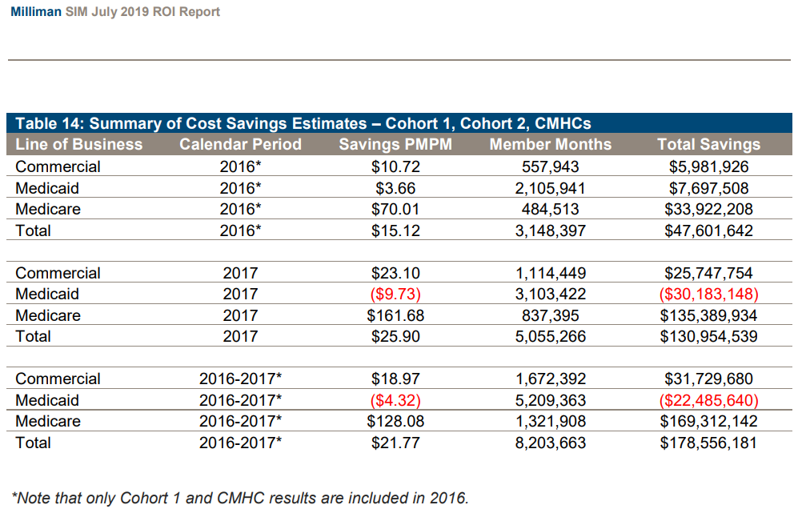

- Expand integrated care training opportunities for the current and future workforce. To further advance integration, key providers, such as primary care providers, behavioral health care providers, and care managers and coordinators, require training in integrated care. Current federal grants that support opportunities for behavioral health providers and paraprofessionals to train in integrated settings could be expanded to meet increasing need for behavioral health integration. State or federal policymakers should also consider funding technical assistance and training opportunities to train current providers and practices interested in implementing integrated care.

- Reimburse evidence-based mental health treatments at their true cost and streamline across payment spectrum to reduce clinical variation. Establishing Medicaid reimbursement rates that are commensurate with the costs of providing care – namely in outpatient and ambulatory settings – should encourage providers to offer evidence-informed treatments that are often available exclusively through grant-funded initiatives in select regions. For example, UPMC Safe Harbor is one of the fourteen First Episode Psychosis (FEP) Programs in Pennsylvania receiving funding through the federal SAMSHA block grant. UPMC Early Onset Recovery Program works with individuals (ages 18-35) who have psychotic disorders early in life as well as their families.

  - Participant characteristics at the time of admission have been summarized for all enrolled (n=66) in the Safe Harbor program between January 1, 2017 – January 1, 2021. As with past quarterly reports, the data demonstrates a pattern of improved outcomes for those in the Safe Harbor program. Our most recent outcomes include:

- 69% decrease in number of participant hospitalizations by 18-month follow-up
- 87% decrease in hospital days by 18-month follow-up on average
- Employment rates increased by 90% at 24-month follow-up
- School enrollment increased by 161% in those over age 18 by 24-mo follow-up
- 100% decrease in individuals attempting suicide at 24-months
- 100% decrease in homelessness by 24-months follow-up
- Decreased adverse behaviors and legal issues
- Decreased substance use

- Support enhanced Medicaid for mobile crisis interventions outside of hospital and facility setting. UPMC resolve Crisis Services provides crisis services to residents of Allegheny County, including walk-in and short-term residential services in Pittsburgh’s East End neighborhood, a call center, and mobile crisis response unit. resolve Crisis Services model mirrors goals of (S. 764) Crisis Assistance Helping Out On the Streets Act (CAHOOTS Act). resolve is a partnership between Allegheny County & UPMC Western. The 150-member team at resolve provides services 24/7/365 without regard to the individual’s ability to pay or insurance coverage; however, more than 70% of consumers are covered through a Medicare/Medicaid (Health Choices) payment mechanism. Crisis centers need to be equipped to deal with ongoing technology changes and communication technologies. Since they respond to disasters and community crisis, they must be able to update infrastructure and have afforded agility.

  - UPMC resolve Crisis Services handled 96,104 telephone calls in CY 2020, a 6.6% increase compared to CY 2019. UPMC served 9,080 people in CY 2020 through our mobile crisis program; more than 80% were diverted from hospital emergency rooms and inpatient care. Less than 10% of the calls required law enforcement to be engaged.

  - In February, after conducting a broad-based study of Pennsylvania county administered, community-based mental health services, the PA Legislative Budget and Finance Committee released a study where it was noted that 74% of county administrators expect crisis calls to increase in the next six-12 months. Studies from the NSPL/9-8-8 planning team anticipate an up to 10-fold increase in call volume over the next five years as 988 becomes widely implemented and promoted.

- HHS to finalize modifications to the HIPAA privacy rule to support and remove barriers to coordinated care and individual engagement. Specifically, the proposals in the Notice of Proposed Rulemaking (NPRM) would amend provisions of the Privacy Rule that could present barriers to coordinated care and case management—or impose other regulatory burdens without sufficiently compensating for, or offsetting, such burdens through privacy protections. These regulatory barriers may impede the transformation of the health care system from one that pays for procedures and services to one of value-based health care that pays for quality.

  - The proposed rule would create an exception to the “minimum necessary” standard for individual-level care coordination and case management uses and disclosures.” This recognizes the importance of “whole person care.”

Supportive Legislation

- Support Senators Collins and Smith’s Bipartisan Bill to Improve Care for Americans with Serious Mental Illnesses. The 190-day lifetime limit on coverage for inpatient psychiatric treatment under Medicare remains an obstacle to parity between behavioral and physical health. With the nation’s population aging and an increasing number of seniors and people with disabilities seeking inpatient care to address their behavioral health needs, now is the time to repeal this discriminatory policy and ensure Medicare beneficiaries can receive the inpatient psychiatric care they need.

- Curbing our nation’s overdose epidemic requires removing regulatory hurdles to medication-assisted treatment (MAT), standardizing prescriber education practices and expanding access to care for our nation’s most vulnerable populations. The Ask: Cosponsor and support the concurrent passage of the Mainstreaming Addiction Treatment (MAT) Act (S. 445/H.R. 1384), the Medication Access and Training Expansion (MATE) Act (S.2235/H.R. 2067) and the Medicaid Reentry Act (S. 285/H.R. 955).

- With a July 2022 launch date for 9-8-8 implementation fast approaching, significant investments are needed to improve and secure the suicide prevention, mental health and substance use crisis care continuum. The Ask: Include the following recommendations in a legislative vehicle to transform and coordinate our nation’s crisis care continuum.
- Fund Lifeline Call Centers and Crisis Response Programs
- Invest in the Physical and Human Infrastructure Needed for the Crisis Care Continuum
- Incentivize Funding Mobile Outreach, Crisis Services and Innovative Care

We are grateful for the opportunity to share these recommendations and we stand ready to work with you.

Sincerely,
Deborah S. Brodine, MBA MHA
President, UPMC Western Psychiatric
President, UPMC Senior Services

Camellia Herisko, DNP, MSN, RN, PMHCNS-BC, CRNP
CNO, VP of Operations and Patient Care Services
UPMC Western Psychiatric Hospital

Jack Rozel, MD, MSL
Medical Director, resolve Crisis Services
Past President, American Association for Emergency Psychiatry

Jody Glance, MD
Medical Director, Addiction Medicine Services of UPMC Western Psychiatric Hospital
Assistant Professor of Psychiatry, University of Pittsburgh School of Medicine
Associate Director of Medical Student Education, University of Pittsburgh Department of Psychiatry
Mandy Fauble, PhD, LCSW (she/her)
Director of Clinical Care Services
UPMC Western Behavioral Health at Safe Harbor

Nicole M. Fedeli
Director, Public Policy & Engagement

NIMH » One Year In: COVID-19 and Mental Health (nih.gov)
American ‘sandwich generation’ caregivers suffer the most (mckinsey.com)
https://www.wsj.com/articles/americans-seek-urgent-mental-health-support-as-covid-19-crisis-ebbs-11624786203?page=1
Nearly 80% of National Council for Mental Wellbeing Members Say Demand for Treatment Has Increased Over the Past Three Months - National Council (thenationalcouncil.org)
Behavioral Health Workforce Projections. Rockville, MD, Health Resources and Services Administration, 2020. Available here: https://bhw.hrsa.gov/data-research/projecting-health-workforce-supply-demand/behavioral-health.
https://thinkbiggerdogood.org/enhancing-the-capacity-of-the-mental-health-and-addiction-workforce-a-framework/
https://www.chcs.org/resource/southwestern-pennsylvania-peers-help-people-with-substance-use-disorders-move-toward-recovery/
National Academies of Sciences, Engineering, and Medicine. 2020. Caring for People with Mental Health and Substance Use Disorders in Primary Care Settings: Proceedings of a Workshop. Washington, DC: The National Academies Press. https://doi.org/10.17226/25927.
Enhancing the Capacity of the Mental Health and Addiction Workforce: A Framework - Think Bigger Do Good
Wallace NT, Cohen DJ, Gunn R, et al.: Start-up and ongoing practice expenses of behavioral health and primary care integration interventions in the Advancing Care Together (ACT) Program. J Am Board Fam Med 28(suppl 1):S86–S97, 2015. Available here: https://www.jabfm.org/content/28/Supplement_1/S86/tab-article-info.
Malâtre-Lansac A, Engel CC, Xenakis L, et al.: Factors influencing physician practices’ adoption of behavioral health integration in the United States: a qualitative study. Ann Intern Med 173:92–99, 2020. Available here: https://www.acpjournals.org/doi/abs/10.7326/m20-0132.
Ross KM, Gilchrist EC, Melek SP, et al.: Cost savings associated with an alternative payment model for integrating behavioral health in primary care. Transl Behav Med 9:274–281, 2019. Available here: https://academic.oup.com/tbm/article-abstract/9/2/274/5001714?redirectedFrom=fulltext.
Reiss-Brennan B, Brunisholz KD, Dredge C, et al.: Association of integrated team-based care with health care quality, utilization, and cost. JAMA 316:826–834, 2016. Available here: https://jamanetwork.com/journals/jama/fullarticle/2545685.
Ross KM, Klein B, Ferro K, et al.: The cost effectiveness of embedding a behavioral health clinician into an existing primary care practice to facilitate the integration of care: a prospective, case-control program evaluation. J Clin Psychol Med Settings 26:59–67, 2019. Available here: https://link.springer.com/article/10.1007/s10880-018-9564-9.
Ross KM, Gilchrist EC, Melek SP, et al.: Cost savings associated with an alternative payment model for integrating behavioral health in primary care. Transl Behav Med 9:274–281, 2019. Available here: https://academic.oup.com/tbm/article-abstract/9/2/274/5001714?redirectedFrom=fulltext.
Sanchez K, Ybarra R, Chapa T, et al.: Eliminating behavioral health disparities and improving outcomes for racial and ethnic minority populations. Psychiatr Serv 67:13–15, 2016. Available here: https://ps.psychiatryonline.org/doi/10.1176/appi.ps.201400581.
Martinez LS, Lundgren L, Walter AW, et al.: Behavioral health, primary care integration, and social work’s role in improving health outcomes in communities of color: a systematic review. J Soc Social Work Res 10:441–457, 2019. Available here: https://www.journals.uchicago.edu/doi/10.1086/704070.
Miranda J, Duan N, Sherbourne C, et al.: Improving care for minorities: can quality improvement interventions improve care and outcomes for depressed minorities? Results of a randomized, controlled trial. Health Serv Res 38:613–630, 2003. Available here: https://onlinelibrary.wiley.com/doi/abs/10.1111/1475-6773.00136.
Malek S, Weaver A, Davenport S: SIM Healthcare Cost Savings and Return-on-Investment Report. Denver, CO, Milliman, Inc. 2019. Available here: https://www.colorado.gov/pacific/sites/default/files/Colorado%20SIM%20Return-on-Investment%20%28ROI%29%20Report.pdf
First Episode Psychosis | NRI: No Person's life will be limited by mental illness or addiction (nri-inc.org)
Case Study: Early Assessment of the Mental Health Block Grant Set-Aside Program for Addressing First Episode Psychosis and Other Early Serious Mental Illness (hhs.gov)

